Industry-Academia Meet Report
A first of its kind Industry Academia Meet was organized on February 01, 2025, in the Auditorium.
The primary objective of this meet was to foster collaboration and knowledge exchange between industry professionals and academia.
With an aim to bridge the gap between theoretical knowledge and its practical application, the interaction was dedicated to a through discussion on changes in the highly dynamic corporate environment to acquaint students with the ever-evolving cultures in the domains of formulation, QA/QC, marketing and sales, supply chain management, packaging, regulatory aspects, research and formulation development, operations, finance and Human resource management etc. or any other emerging field, ensuring students are equipped with the skills and insights needed for success in the industry.
The target recipients were the students of Final Year B. pharm, Third year B. Pharm + MBA and M. Pharm / M. Pharm + MBA, First and Second Year Students.
Following dignitaries participated in this meet.
- Mr. Ankush Jamdagni, Co-Founder Oatey inc.
- Mr. Rishi Nagar, Founder and Head, Fitnastic India.
- Mr. Prahlad Pandey, Trainer and founder Prahlad Pandey Corporation
- Ms. Shilpy Singh, Head - Project Management & Technology Transfer, Piramal Healthcare, Indore
- Mr. Suhas Choudhari, Sr. General Manager – Packaging, Serum Institute of India, Pune
- Dr. Khusro Salim Kazi, Group CEO, EMC Group of Hospitals
- Dr. Nandkumar Patil, Head and Associate Vice President, Regulatory Affairs, Apicore Pharmaceuticals, RK Pharma group Company.
Dr. Shyamsunder Pancholi, Associate Dean, SPTM, Shirpur welcomed the speakers and introduced them with the theme of the meet. In his address, he gave a brief presentation about the School and its facilities. He highlighted the avenues, where the school can extend its hands for collaboration with industry.
The panellists for the first panel discussion were Mr. Ankush J, Mr. Rishi Nagar, Mr. Parhlad Pandey and Ms. Shilpy Singh. This discussion was moderated by Dr. Shyam Sunder Pancholi; Asso. Dean; SPTM, Shirpur. This discussion was planned between 11.00 am to 02.00 pm
While panellists for another were Mr. Suhas Choudhari, Dr. Nandkumar Patil and Dr. Kazi Khusro. This discussion was moderated by Dr. Girdharilal Gupta; Professor; Pharmacology; SPTM were moderators for the session. This discussion took place between 03.00 to 07.00 pm.
Key Discussions:
- Industry Trends: Industry experts shared insights into the latest trends, challenges, and opportunities in their respective fields. They told students that major fields where students should look in to are, data analytics, business analytics, Bio AI Pharmacovigilance, Technology Transfer, etc.
- Skill Requirements: Discussions focused on the specific skills and competencies that industries seek in graduates. The panellists discussed the importance of time management, management of the attitude, adaptability, how to tackle a problem, importance of mind-set and skill-set. The discussion further emphasised the importance of being creative, team player, self-initiation, being experimentative, ready to fail and discover new opportunities, as a required skill-set for the students of this generation.
- Preparation for interview: The panellists emphasised on important skills required for the interviews. They told to create the resume, which will highlight key words, which are in an alignment with job requirement as well as reflecting the personality of oneself. While preparing for the interviews, one should have a thorough knowledge of the company, particularly its products, working culture, and present job responsibilities. Though importance of the academic preparation cannot be neglected, importance is about your fearlessness, body language, mind-set, and inquisitiveness carries an equal weightage they said. They also emphasised on role of extracurricular activities in grooming the personality, particularly self-initiation, sharing ideas, being the part of the team, leadership qualities etc.
- Research Collaboration: Opportunities for joint research projects and industry-academia partnerships were explored. During the discussion, the panellists discussed the possibilities and avenues of the industry – academia collaboration. It was further a suggestion from the panellists that students of M. pharm, should undertake a research project identifying current need of the industry and society in turn.

Outcomes:
- Internship Opportunities: Industry representatives expressed interest in providing internship opportunities to students.
- Collaborative Projects: Potential areas for collaborative research projects were identified.
- Networking: The meet provided a platform for students and faculty to network with industry professionals.
Conclusion:
The industry-academia meet was a successful event that facilitated meaningful dialogue and collaboration between industry and academia. It provided valuable insights into industry needs and helped identify areas for improvement in curriculum and research. The outcomes of this meet will contribute to better preparing students for the challenges and opportunities of the industry.
To conclude the meet, Dr. Amit Page, Co-ordinator of the meet, summarised the discussion and presented the vote of thanks.
Please find the glimpses of the meet on…

https://drive.google.com/drive/folders/1FPJRePjCJIirOnsgkPFvOHhWS0qA4JX2?usp=drive_link

Glimpses of the meet
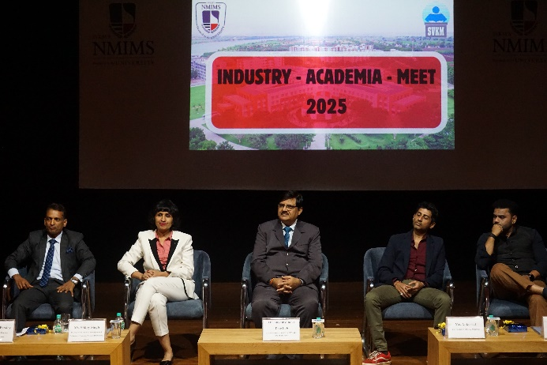 | 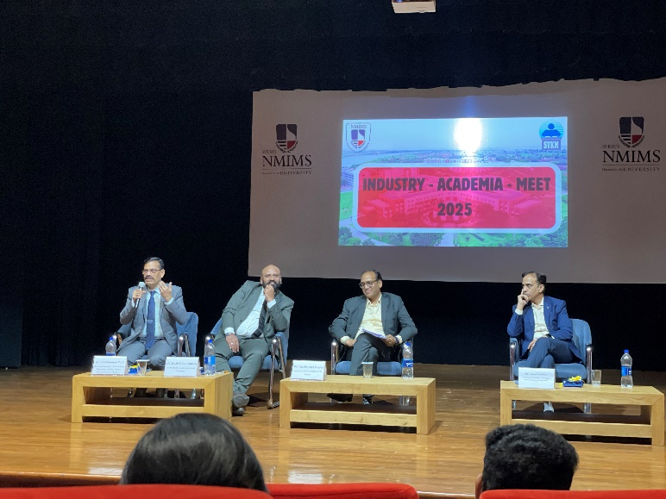
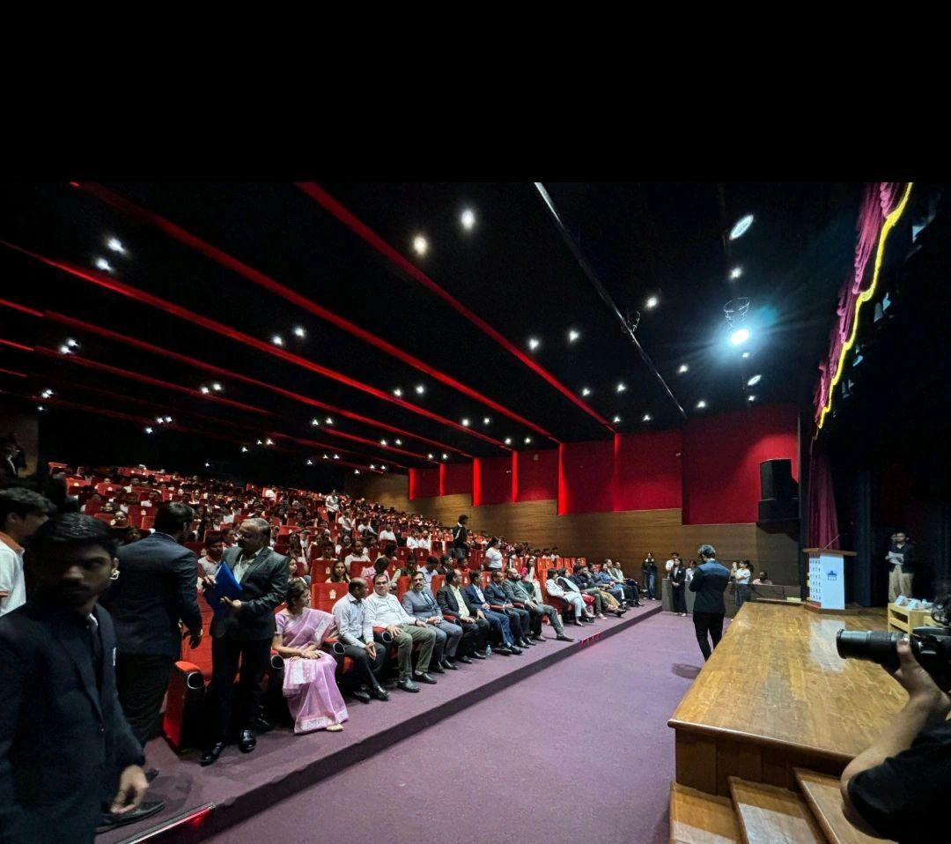 | 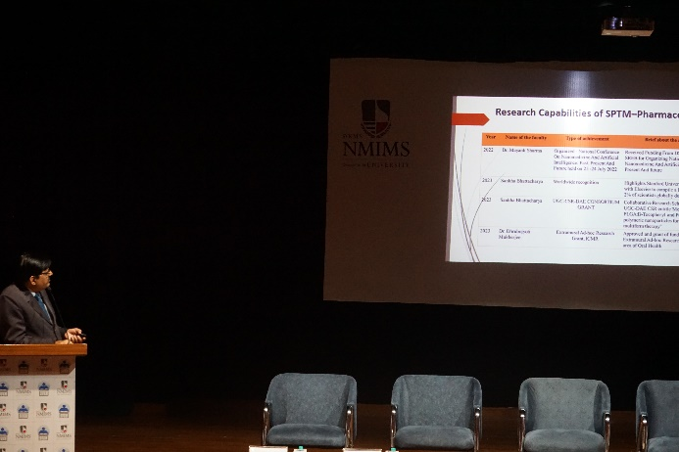
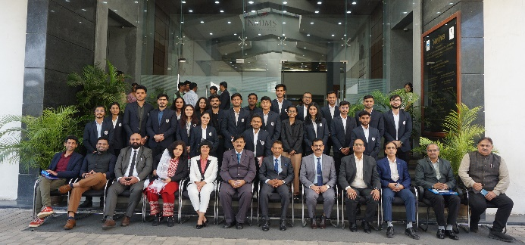 | 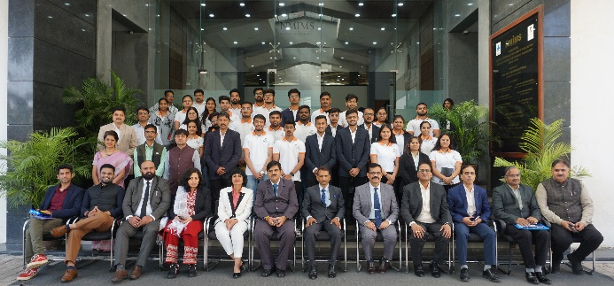
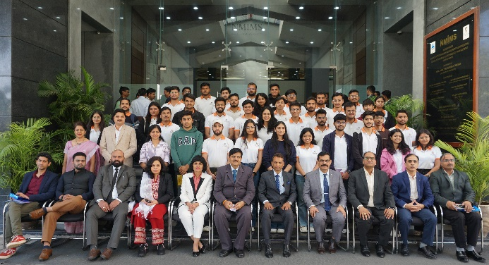 | 